Create a resource group by using name , location and tags through PowerShell or azure portal

**PowerShell commands:**

**Account-connect:**

Connect-AzAccount

**Resource group creation:**

New-AzResourceGroup -Name mysql -Location eastus -tag @{'resources'='my sql'}

Get-AzResourceGroup -ResourceGroupName mysql

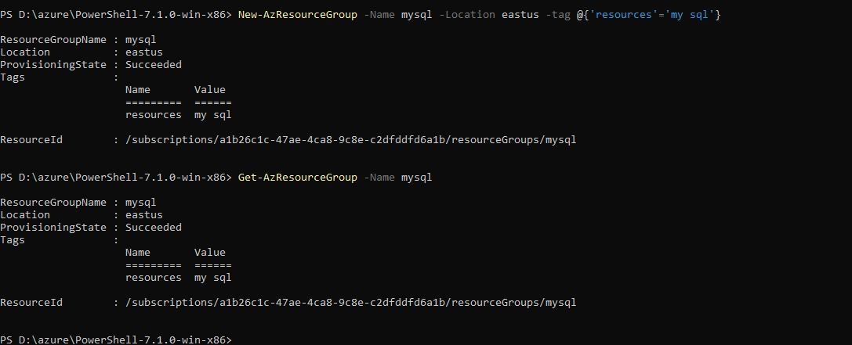

**Deploy arm template with locally stored json files:**

New-AzResourceGroupDeployment -Name testsql -ResourceGroupName mysql -TemplateParameterFile "D:\azchlg\my sql\azuredeploy.parameters.json" -TemplateFile "D:\azchlg\my sql\azuredeploy.json"

**Deploy arm template using uri:**

New-AzResourceGroupDeployment -Name testsql -ResourceGroupName mysql -TemplateUri ' https://raw.githubusercontent.com/kamalanathan1995/azchlg/master/my%20sql/azuredeploy.json' -TemplateParameterUri 'https://raw.githubusercontent.com/kamalanathan1995/azchlg/master/my%20sql/azuredeploy.parameters.json'

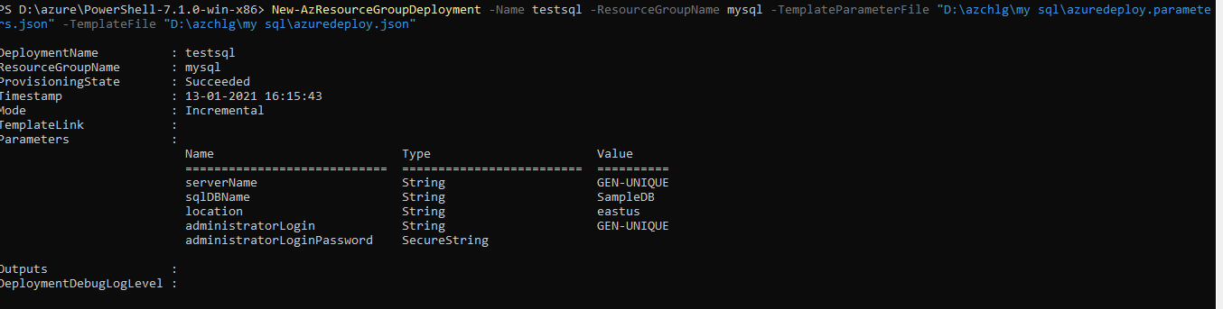

PS D:\azure\PowerShell-7.1.0-win-x86> Get-AzResource -ResourceType "Microsoft.Sql/servers" -ResourceGroupName mysql -ApiVersion 2015-01-01

Name : GEN-UNIQUE

ResourceGroupName : mysql

ResourceType : Microsoft.Sql/servers

Location : eastus

ResourceId : /subscriptions/a1b26c1c-47ae-4ca8-9c8e-c2dfddfd6a1b/resourceGroups/mysql/providers/Microsoft.Sql/servers/GEN-UNIQUE

Tags :

Use the below link to get more mysql powershell commands:

https://docs.azure.cn/en-us/mysql-database-on-azure/mysql-database-commandlines